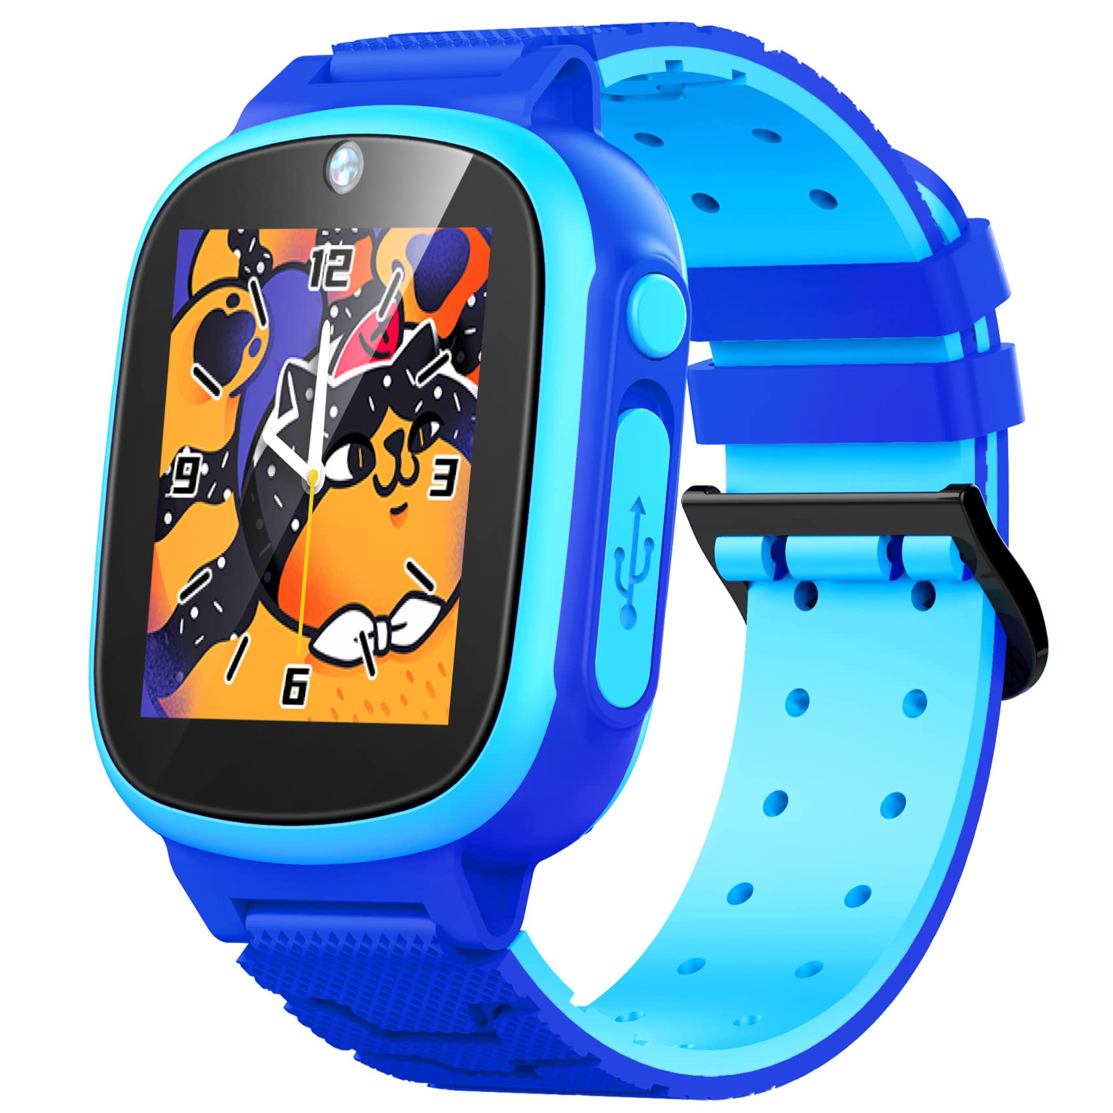**Description:** Casio Baby-G is a line of stylish and durable watches designed for women, offering a combination of toughness and fashion. Launched in 1994 as a smaller, more colorful version of the popular G-Shock series, Baby-G watches feature shock resistance, water resistance, and various digital functions like world time, alarms, and stopwatch. Known for their sporty yet trendy designs, these watches cater to active lifestyles while maintaining a youthful and fashionable appeal. With a mix of vibrant colors, sleek aesthetics, and rugged performance, Baby-G remains a popular choice for those looking for both functionality and style in a timepiece.